Operational Concept Description (OCD)

LADOT Scanning

Team # 8

Team Members & Roles:
Name | Primary Role | Secondary Role
Aditya Kumar | Feasibility Analyst | Project Manager
Anirudh Govil | Project Manager | Life Cycle Planner
Corey Painter | IIV&V | Shaper
Jeffrey Colvin | Prototyper | Systems and software architect
Niraj Brahmkhatri | Operational Concept Engineer | Requirements Engineer
Nisheeth Joshi | Systems and Software Architect | Life Cycle Planner

Version History
Date | Author | Version | Changes made | Rationale
09/26/11 | Niraj Brahmkhatri | 1.0 | - Original Template v 1.0 | - Initial draft v1.0
10/03/11 | Nisheeth Joshi | 1.1 | - Original Template v 1.0 | - Initial draft v1.0
10/03/11 | Niraj Brahmkhatri | 1.2 | - Original Template v 1.0 | - Initial draft v1.0
10/06/11 | Niraj Brahmkhatri | 2.0 | - Completed section 3 of OCD | - Updated after WinWin negotiations
10/06/11 | Nisheeth Joshi | 2.1 | - Completed section 3 of OCD | - Updated primary and secondary role
10/10/11 | Niraj Brahmkhatri | 2.2 | - Completed section 3.3 | - Business work flow diagram and ER diagram added  - Benefits analysis diagram updated
10/14/11 | Niraj Brahmkhatri | 2.3 | - Completed sections 3.1.3 & 3.3.2 | - Business work flow diagrams have been done using RSM tool
10/17/11 | Niraj Brahmkhatri | 2.4 | - Section 3.3.2 | - System maintainer is no more a part of the new system
10/19/11 | Niraj Brahmkhatri | 2.5 | - Sections 2.4 , 2.5 and 3.3.2 | - Business workflow diagram, benefits-chain diagram and system boundary diagram have been updated
10/23/11 | NB | 2.6 | - Sections 2.4, 2.5, 3.2 and 3.3 | - Updated after the ARB session
10/31/11 | NB | 3.0 | - Sections 2.3 & 3.2.1 | - Generating a FLAT file in DTIME format is no more a requirement
11/07/11 | NB | 3.1 | - Sections 2.4, 3.2 and 3.3 | - Updated after getting feedback from the IV&V
11/20/11 | NB | 4.0 | - Section 3.2 | - Capability requirements have changed a little after CCD
11/28/11 | NB | 4.1 | - Section 1.2 and 3.3.1 | - Updated after getting feedback from the IV&V
12/01/11 | NB | 4.2 | - Section 2.1 | - Employees of the payroll dept are not success-critical stakeholders anymore
12/05/11 | NB | 4.3 | - Section 2.1 | - Maintainer has been added as a success-critical stakeholder

Table of Contents
Operational Concept Description (OCD) …………………………………………………………………………...i
Version History ………………………………………………………………………………………………………ii
Table of Contents ……………………………………………………………………………………………………iii
Table of Tables ………………………………………………………………………………………………………iv
Table of Figures ……………………………………………………………………………………………………...v

1. Introduction………………………………………………………………………………………………...........1
1.1 Purpose of the OCD ………………………………………………………………………………………..1
1.2 Status of the OCD …………………………………………………………………………………………..1
2. Shared Vision …………………………………………………………………………………………………...2
2.1 Success-Critical Stakeholders ……………………………………………………………………………...2
2.2 System Capability Description …………………………………………………………………………….3
2.3 Expected Benefits …………………………………………………………………………………………...3
2.4 Benefits Chain ………………………………………………………………………………………………4
2.5 System Boundary and Environment ………………………………………………………………………5
3. System Transformation …………………………………………………………………………………………6
3.1 Information on Current System …………………………………………………………………………...6
3.2 System Objectives, Constraints and Priorities………………………………………………….………..8

3.3 Proposed New Operational Concept……………………………………………………………………..11

3.4 Organizational and Operational Implications………………….………………………………………...13

Table of Tables

Table 1: Success-Critical Stakeholders …………………………………………………………………………………………2
Table 2: Artifacts …………………………………………………………………………………………………………………..6
Table 3: Level of Service Goals…………………………………………………………………………………………………..9
Table 4: Relation to current system……………………………………………………………………………………………..10

Table of Figures
Figure 1: Benefits Chain Diagram of the LADOT Scanning……… ………………………………………………………..4
Figure 2: System Boundary and Environment Diagram of the LADOT Scanning………………………………………..5
Figure 3: Current Business Workflow…………………………………………………………………………………………..7
Figure 4: Element Relationship Diagram of the LADOT Scanning……………………………………………………….11
Figure 5: Business Workflow Diagram for the truck system…….………………………………………………………….12

Introduction

Purpose of the OCD

This document provides, in detail, the shared visions and goals of the stakeholders of the Timesheet Scanning System for the Los Angeles Department of Transportation (LADOT). The success-critical stakeholders of the project are the client – Mr. Richard Harada and the users including LADOT & LA City employees.

Status of the OCD

The project is currently in the version number 4.3 of Development phase. We have redefined the scope of the project after client meetings, winwin negotiations, ARB session and CCD.

Shared Vision

Success-Critical Stakeholders
Table 1: Success-Critical Stakeholders
Stakeholder | Authorized Representatives | Organization | Relation to Benefits Chain
Client | Mr. Richard Harada | Los Angeles Department of Transportation(LADOT) | - Fiscal systems specialist  - Responsible for analyzing and sanctioning proposals for a new scanning system.  - Provide technical training to the prospective users.
Field Workers | A crew of ~120 people | Los Angeles Department of Transportation(LADOT) | - Do signal maintenance in the field daily.  - Fill up their time sheets on a regular basis.
Supervisors | Employees of LADOT who supervise the activities of field workers | Los Angeles Department of Transportation(LADOT) | - Delegate different tasks to field workers  - Supervise the progress of work done by field workers
Maintainer | Mr. Mony Patel | Los Angeles Department of Transportation(LADOT) | - Make sure that the truck system is installed on all the trucks
Developers and IV&V | Niraj Brahmkhatri, Aditya Kumar, Nisheeth Joshi, Jeffrey Colvin, Anirudh Govil and  Corey Painter | University of Southern California(USC) | - Manage and develop a new scanning system for the client  - Verify the system’s design and functionality  - Moderates discussion between the client and the development team

System Capability Description
The LADOT requires a truck system that will enable the employees of LADOT to electronically store the maintenance data of field workers who daily perform tasks related to traffic signal maintenance. As the LADOT requirements are specific, it is difficult to obtain a new readymade system that will meet their needs and hence, there is no competitor for the system.

Expected Benefits

- The new system will help LADOT employees eliminate a lot of paper work involved in storing maintenance data.

- Standardization of tasks and validation of work order codes would lead to less time & fewer errors in entering the maintenance information.

Benefits Chain
Figure 1: Benefits Chain Diagram

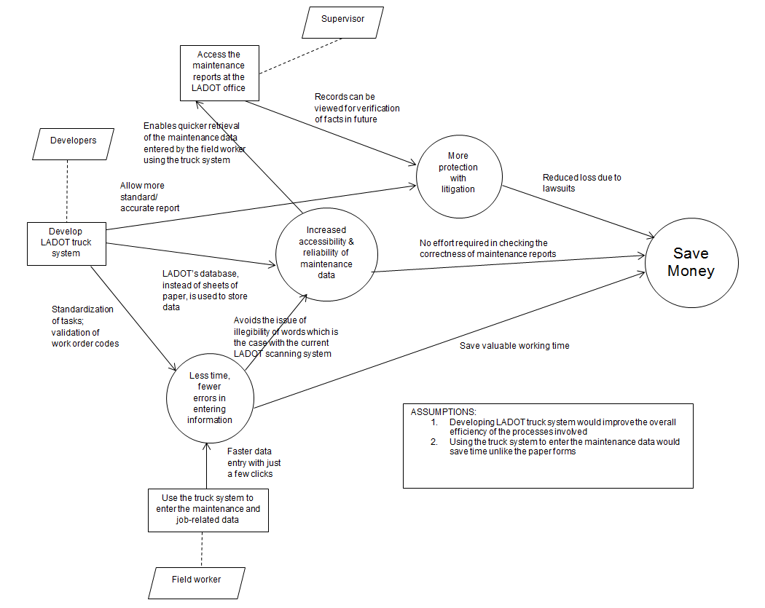

System Boundary and Environment
Figure 2: System Boundary and Environment Diagram
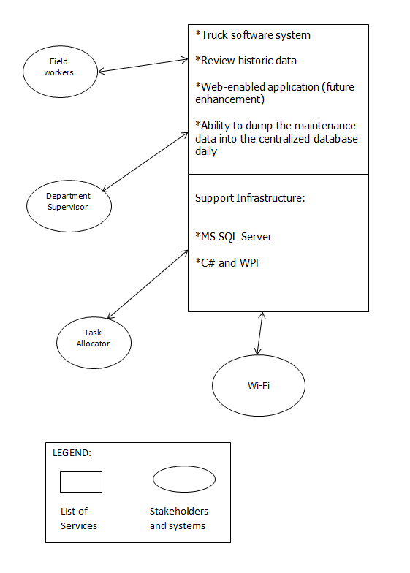

System Transformation

Information on Current System

3.1.1 Infrastructure
The client uses the following software tools:

- Database system: Microsoft SQL Server 7.0
- Scanning application: Teleform by Cardiff
- Operating Systems: Windows 95/98/NT
- Network: Client has a company Intranet.
- Hardware: Desktops, scanner, CDs

Artifacts
Sr. No. | Artifact | Description
1. | Timesheets | Each employee has a separate timesheet, which lists the issue he’s work on, number of hours spent on resolving the issue, and the location of the site of the issue.
2. | OCR scanner | It scans the timesheets of the employees line by line and character by character.
3. | TELEform by Cardiff | This is the software package for the scanner, which reads the timesheets for the employees, in case any characters are not identified, it shows suggestions and asks the user for an appropriate selection.
4. | Department of Transportation Cost System (DOTCS) | It creates an index on the location of the physical timesheet so they could be retrieved in case of litigation purposes and it also creates reports for billing purposes.
5. | MS SQL Server 7.0 database | All the details scanned from the timesheets of the employees are parsed into this database.
6. | DTIME | Payroll system used by all employees. Employees access it through network. For the few employees that use paper time cards, the scanner system is used to input the data into the system

Current Business Workflow

Figure 3: Current Global Business workflow

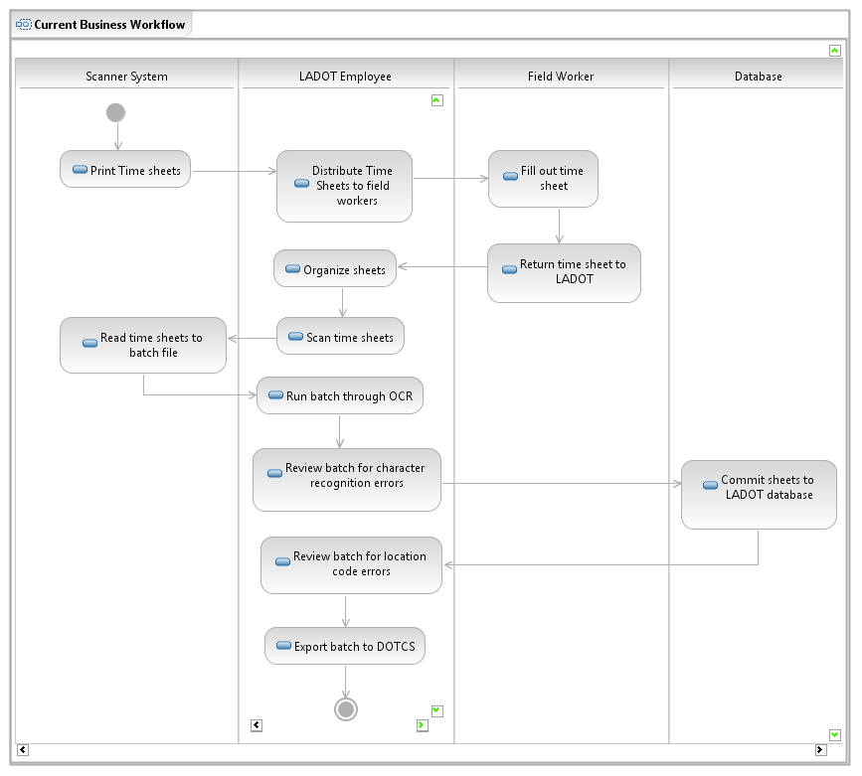

System Objectives, Constraints and Priorities

Capability Goals

OC-1 Error Checking
Error checking/Validation on the work order code must be done by the truck system

OC-2 Log In
The field worker signs in at the beginning of his work.

OC-3 Log Out
The field worker signs off after his work ends.

OC-4 Export file
Export file upon log out for reading in SQL database

OC-5 View Reports
Employees can review their reports by clicking the “View Report” button

Level of Service Goals
Level of Service Goals | Priority Level | Referred SSRD requirements
Table 3: Level of Service Goals
There are no service goals as of now

Organizational Goals
The Payroll Scanning project was brought to the City of Los Angeles for the crews that are doing signal maintenance in the field daily. Currently, their timesheets are hand written on preprinted forms. Hand written notes are written on the back of the times sheets that explain the problem and resolution. This is critical because this data is used to defend the CITY in court when there is an accident at an intersection and issues of maintenance become very important. A judgment against the CITY could potentially be in the millions of dollars.

This new system will replace the old software/hardware and provide a more efficient means of getting payroll data from the field crew into our centralized payroll system. The new system would be less labor intensive! The new system may use different technology for the field crews.
This system will provide these expected benefits in pursuit of these goals:

OG-1: Improve the process of reporting time and maintenance information by using a user-friendly laptop installed on trucks

OG-2: Allow supervisors to review the maintenance data after it’s sent to the respective database
OG-3: Eliminate the amount of paper work in the new system.

Constraints
N/A

Relation to Current System

Capabilities | Current System | New System
Roles and Responsibilities | -The LADOT supervisor has to wait for the timesheets having maintenance data to be received on time. | -Maintenance data can be submitted using wi-fi at the yards.
User Interactions | - Employees use paper sheets to enter their time and maintenance data.  - Employees manually enter maintenance data. Papers sheets have to be archived for reference. | -The employees will enter their maintenance data into the forms on the truck system that will ultimately be stored in LADOT’s MS SQL Server.  - Error checking/ validation of work order codes drastically makes the system less labor-intensive
Infrastructure | -After every 14 days timesheets have to be scanned manually | - (Future Capability) After every 14 days, timekeeping data would be sent to the DTIME database.
Future Capabilities | - Change the fields of the form.  - Improve the Scanning system’s capability to read data reliably | - GPS can be used to track the location of employees.  - Devise a mechanism to provide continuous online connectivity.  - Scaling up the system to handle higher online traffic.

Table 4: Relation to Current System

Proposed New Operational Concept

Element Relationship Diagram
Figure 4: Element Relationship diagram

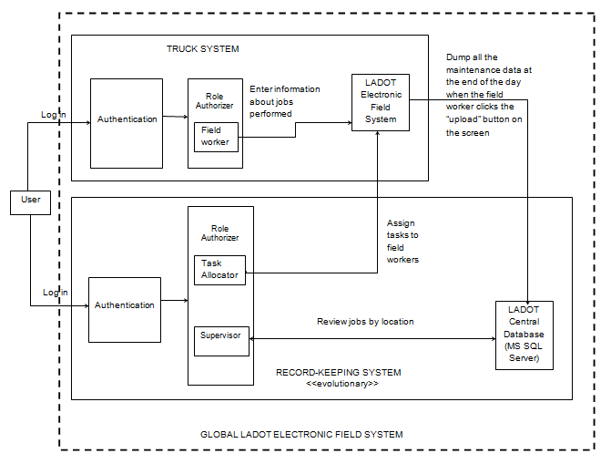

Note: The truck system and the record-keeping system are two separate subsystems of the global LADOT electronic field system. Out of these, only the truck system will be implemented by the end of this semester.

    - Business Workflows

Figure 5: Business workflow for the entire LADOT electronic field system

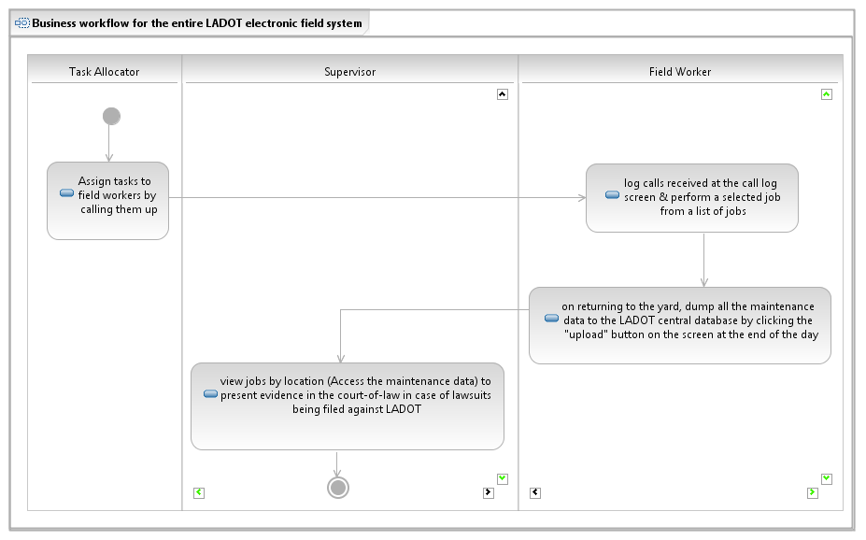

3.4 Organizational and Operational Implications

Organizational Transformations

- Elimination of scanner and paper work currently being used in the system.
- Need of a database administrator who can ensure regular dumping of maintenance data into the SQL server database.
- The need to designate a maintainer who will manage the system’s functionalities and ensure users’ accessibility to the system.
- The improved responsibility of the supervisor to track the activities of employees doing signal maintenance in the field.

Operational Transformations

- The option for employees to fill out and submit their timesheets using the truck software system.
- Transitioning from Teleform to the web based forms.
- Administrator, Department heads and users will have to act in accordance to the flow of process outlined in the truck system.

